CASE # 10A

1.- Create an appointment for:
- Patient: Davis, Ryan
- Day: Next Monday at 10:00 a.m.
- Provider:
- Notes: See the lab first.
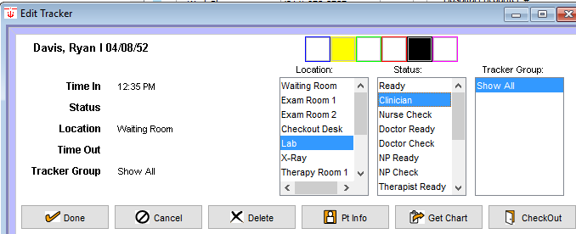
2.- Track this patieny today like this image:

3.-

3.- Enter to the patient’s chart and take the vitals only like this image:
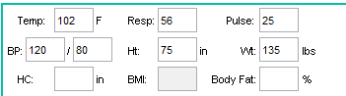

5.-

4.- Create a new refill like this image and save.
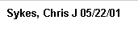
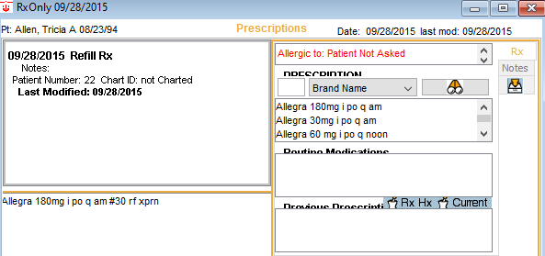
5.- Create a like this image and save.
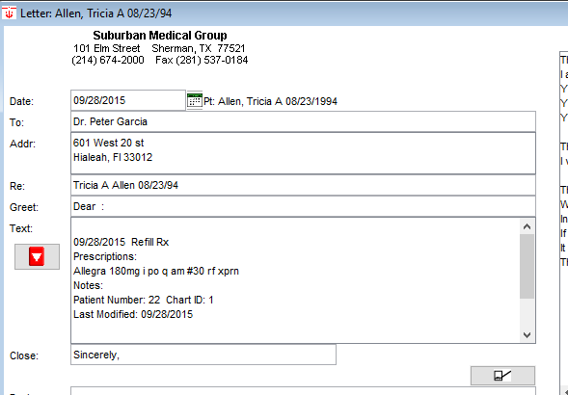
6.- Create a like this image and save
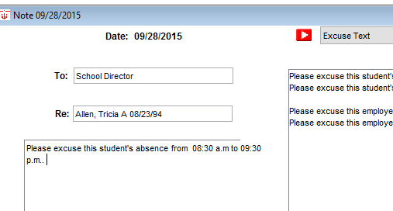

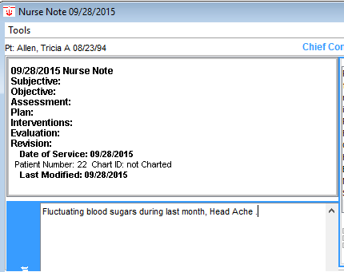
7.- Create a like this image and

8.- Create a like this image and
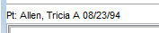
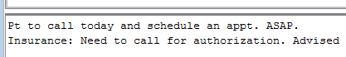

9.- Set the default farmacy to like this image:
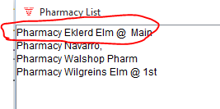

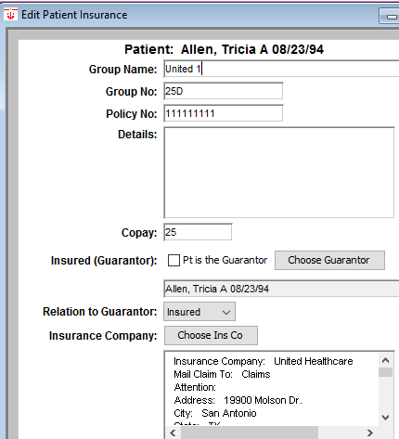
10.- Change the insurance company information:

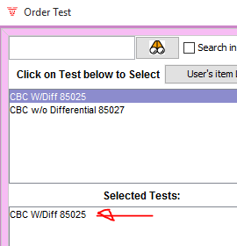

11.- Order a New CBC test for this patient.

12.- The result of pending CBC was:
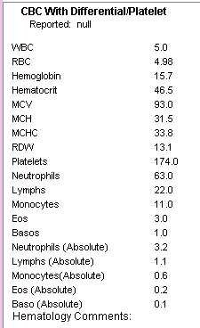

13.- Create a new to do list like this:
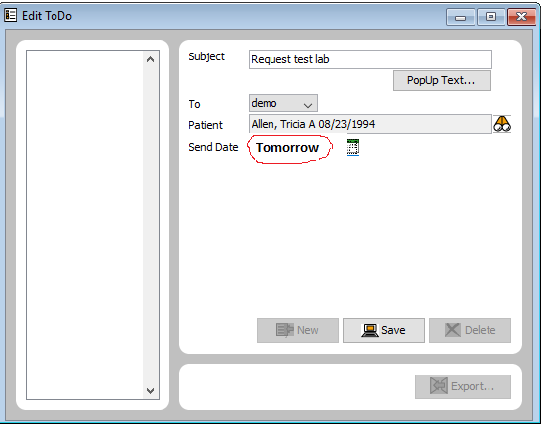

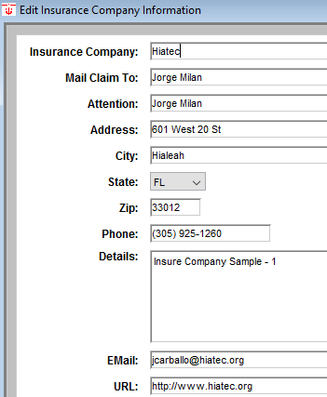
14.- Create this insure company:

15.- Create this message and Chart it:
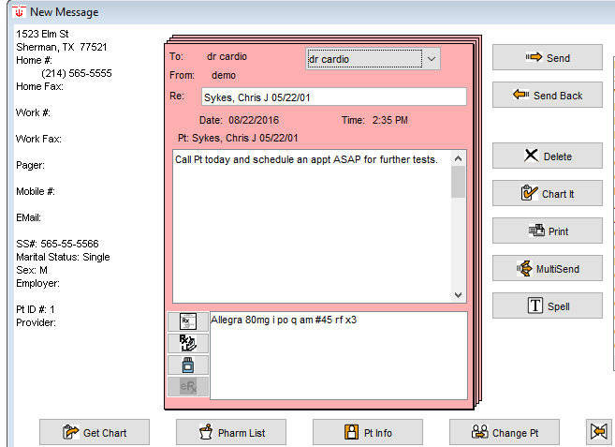

16.- Create this new address card:
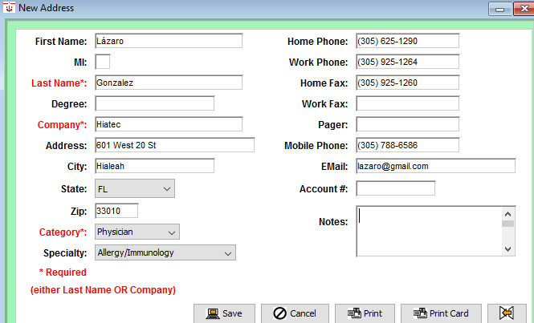

17.- Add this file cabinet document. Attach some doc.
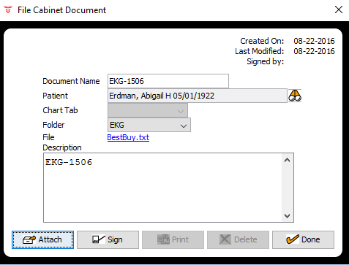

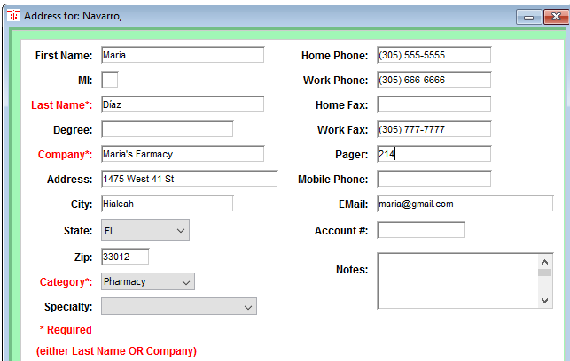
18.- Create this new farmacy:

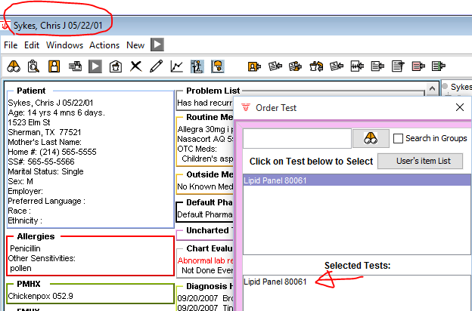
19.- Order this test:

20.- Fill the result for the pass test:
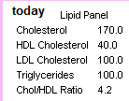

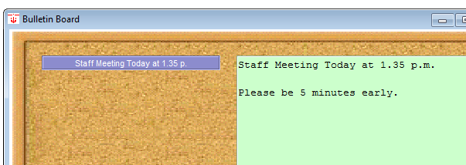
21.- Add a new bulletin board like this image:

22.- Calc the delivery date like this image:
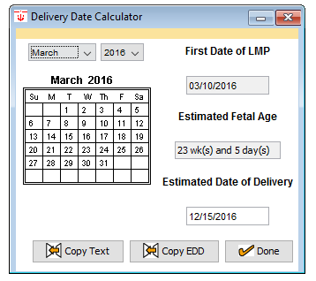

23.- Calc the Fº like this image:
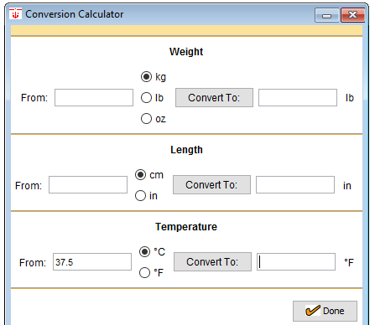

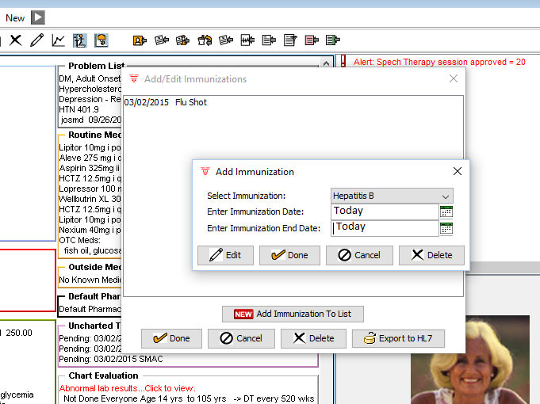
24.- Add a new immunization like this image:

