CASE # 5

1.- Create an appointment for:
- Patient: Allen, Tricia A.
- Day: Next Monday at 9:30 a.m.
- Provider: Stephen M.D.
- Notes: Blood Pressure Check, Albumin Test
2.- Track Adams, Patti today like this image:
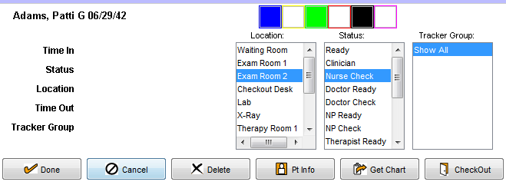

3.- Enable the track views like this image:
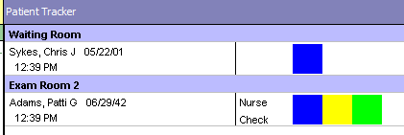

4.- Enter to the patient’s chart and take the vitals only like this image:
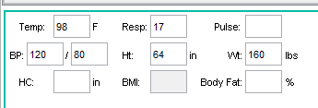

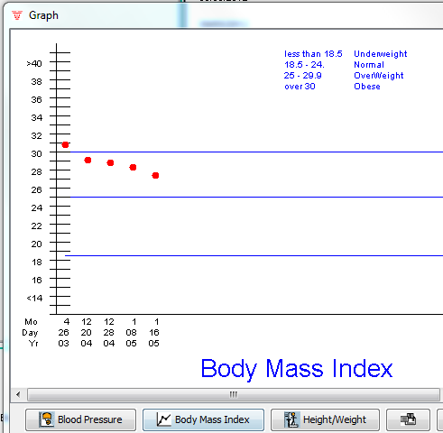
5.- Show this graph:

6.-
7.- Create a new refill like this image and save.
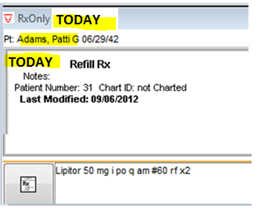

8.- Create a like this image and save.
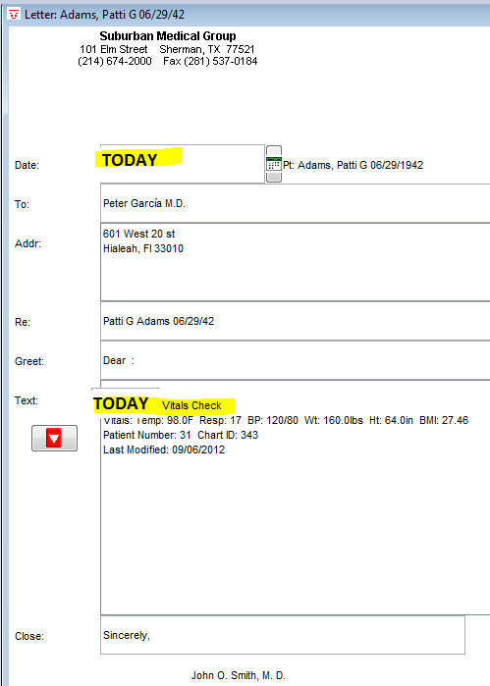

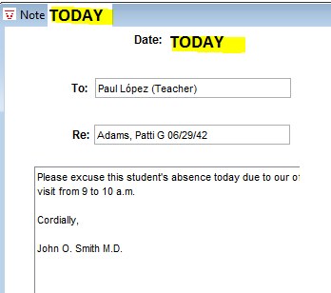

9.- Create a like this image and save

10.- Create a like this image and
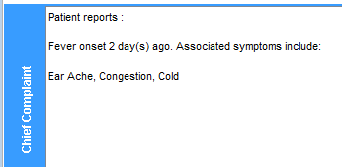

11.- Create a like this image and
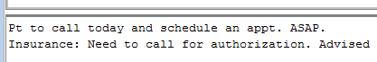

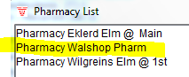
12.- Set the default farmacy to Adams Patti like this image:

