CASE # 6

1.- Create an appointment for:
- Patient: Roland E. Diamond
- Day: Next Tuesday at 11:30 a.m.
- Provider: John O. Smith
- Notes: Blood Pressure Check
2.- Track Sykes, Chris today like this image:
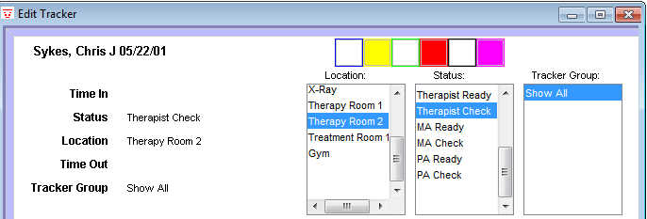

3.- Enable the track views like this image:
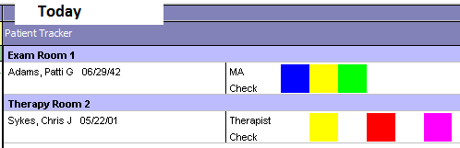

4.- Enter to the patient’s chart and take the vitals only like this image:
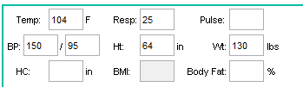

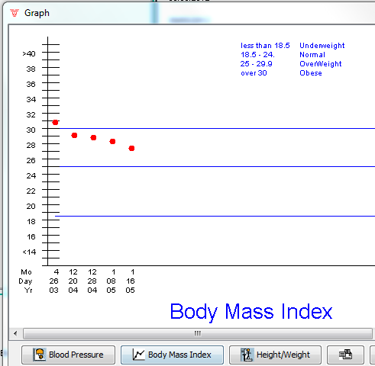
5.- Show this graph:

6.-
7.- Create a new refill like this image and save.
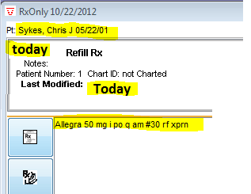

8.- Create a like this image and save.
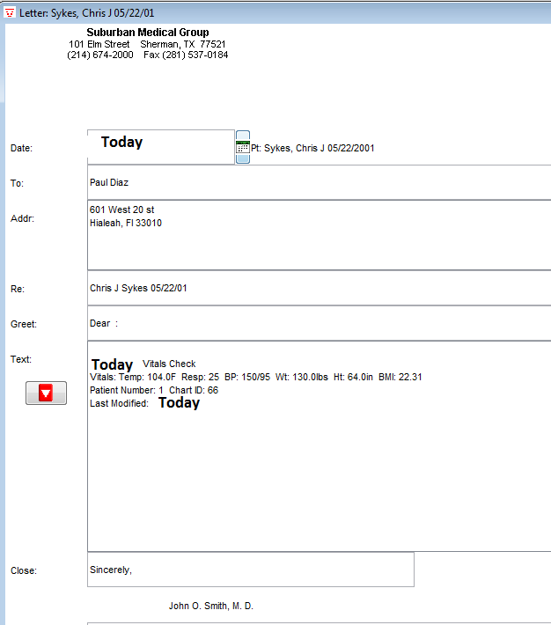

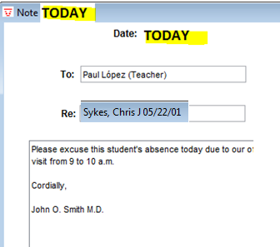
9.- Create a like this image and save

10.- Create a like this image and
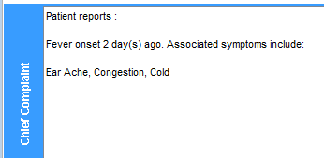

11.- Create a like this image and
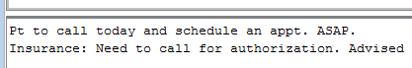

12.- Set the default farmacy to like this image:
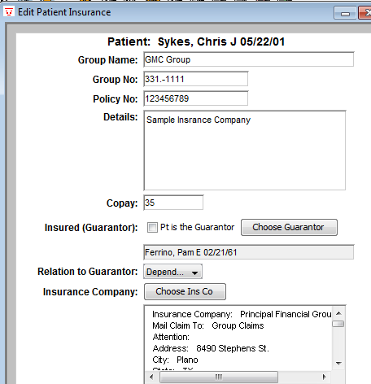
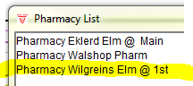

13.- Change the insurance company information:

