CASE # 7

1.- Create an appointment for:
- Patient: Ben T. Kingsbury
- Day: Next Friday at 10:00 a.m.
- Provider:
- Notes: See the lab first.
2.- Track Ben T. Kingsbury today like this image:
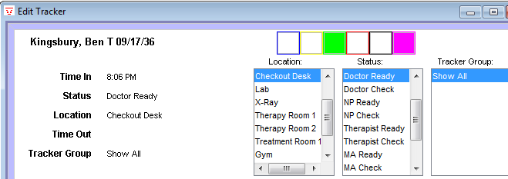

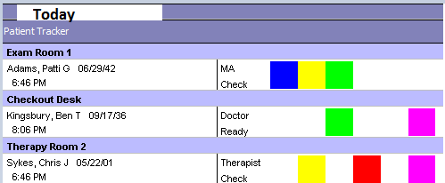
3.- Enable the track views like this image:

4.- Enter to the patient’s chart and take the vitals only like this image:
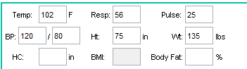

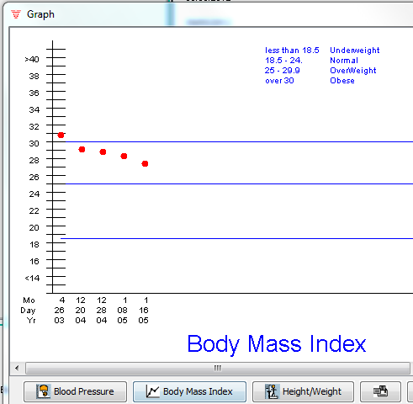
5.- Show this graph:

6.-
7.- Create a new refill like this image and save.
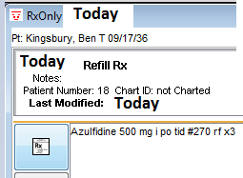

8.- Create a like this image and save.
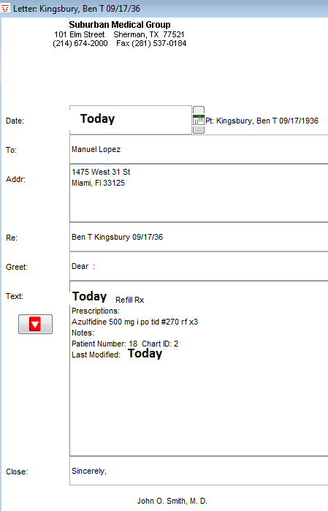

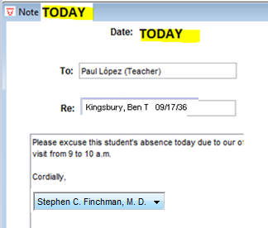

9.- Create a like this image and save

10.- Create a like this image and

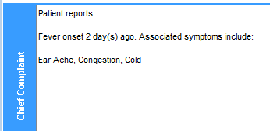

11.- Create a like this image and
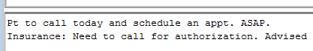

12.- Set the default farmacy to like this image:
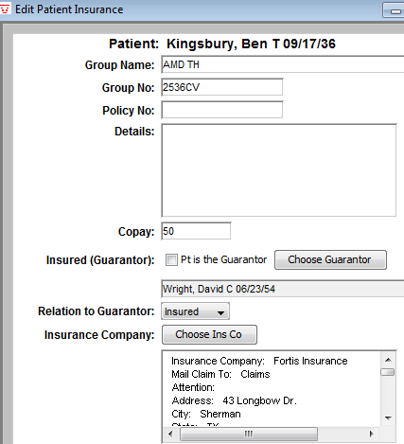
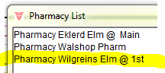

13.- Change the insurance company information:

14.- The result of pending CBC was:
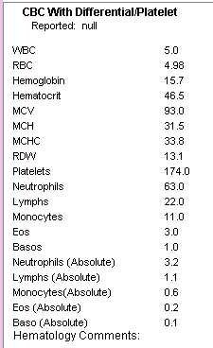

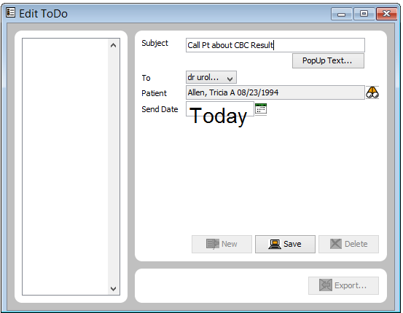
15.- Create a new to do list like this:

16.- Create this insure company:
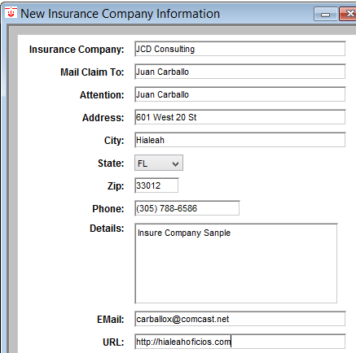

17.- Create this message and Chart it:
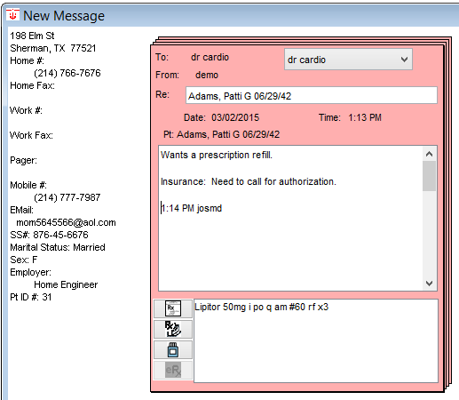

18.- Create this new address card:
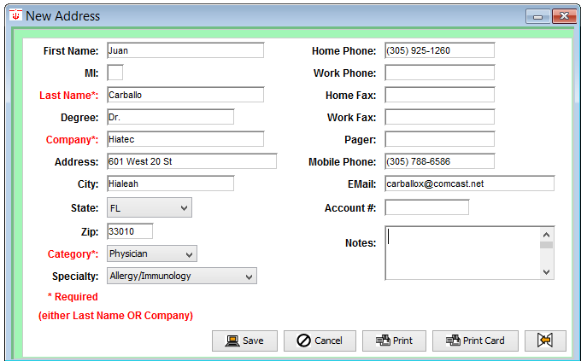

19.- Add this file cabinet document. Attach some doc.
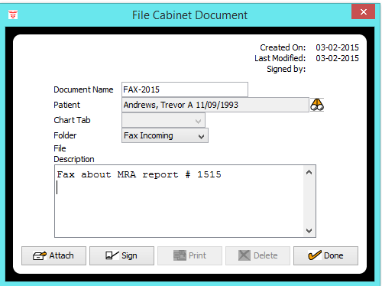

20.- Create this new farmacy:
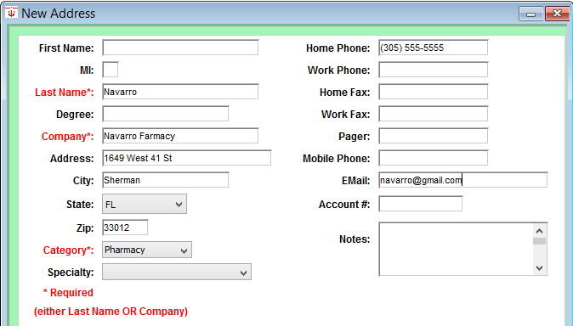

21.- Order this test:
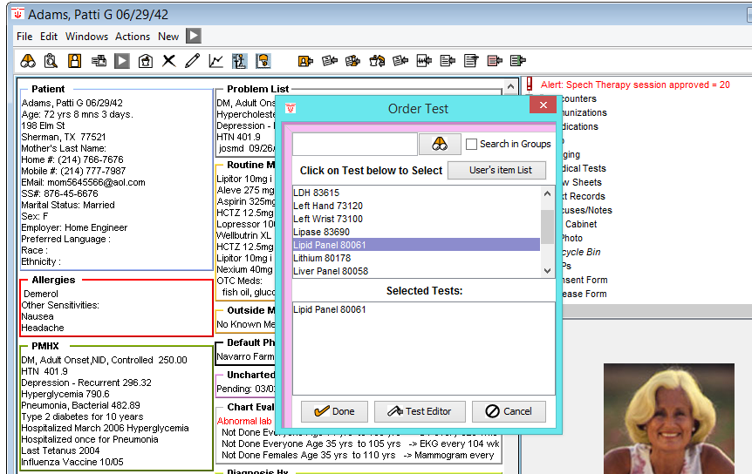

22.- Fill the result for the pass test:
