CASE # 8A

1.- Create an appointment for:
- Patient: Allen, Tricia A.
- Day: Next Friday at 10:00 a.m.
- Provider:
- Notes: See the lab first.
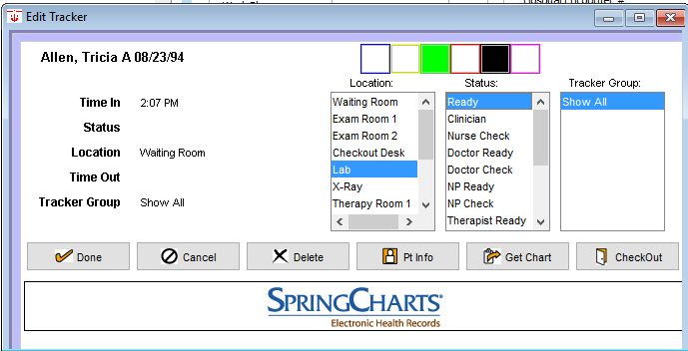
2.- Track Allen, Tricia A. today like this image:

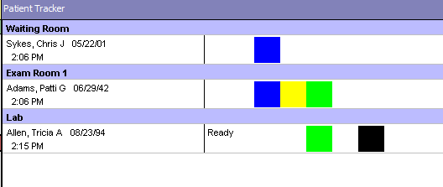
3.- Enable the track views like this image:

4.- Enter to the patient’s chart and take the vitals only like this image:
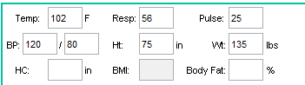

5.-
6.- Create a new refill like this image and save.
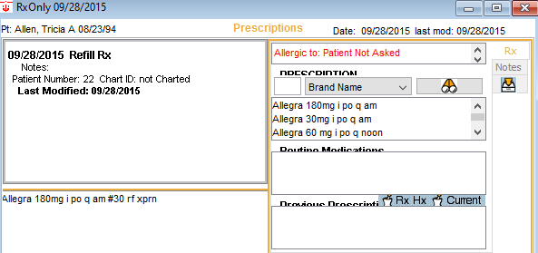
7.- Create a like this image and save.
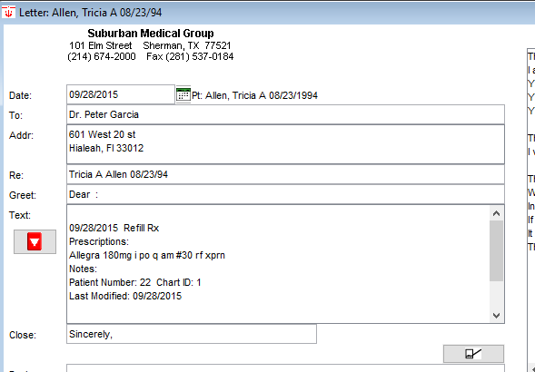
8.- Create a like this image and save
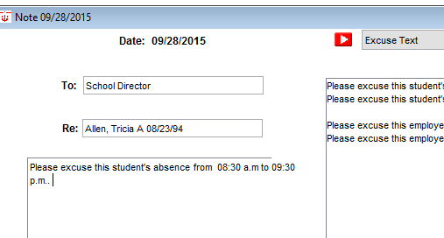

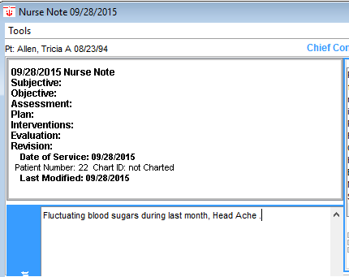
9.- Create a like this image and

10.- Create a like this image and
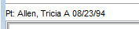
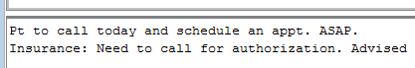

11.- Set the default farmacy to like this image:
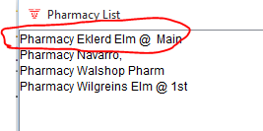

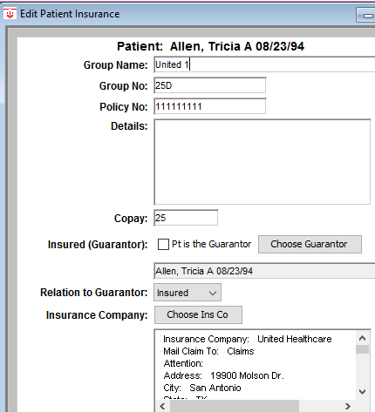
12.- Change the insurance company information:

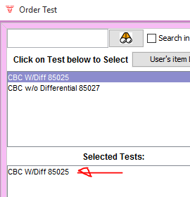

13.- Order a New CBC test for this patient.
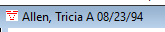

14.- The result of pending CBC was:
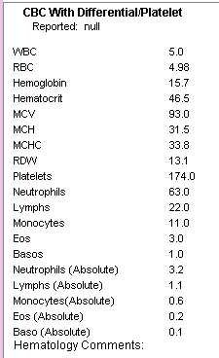

15.- Create a new to do list like this:
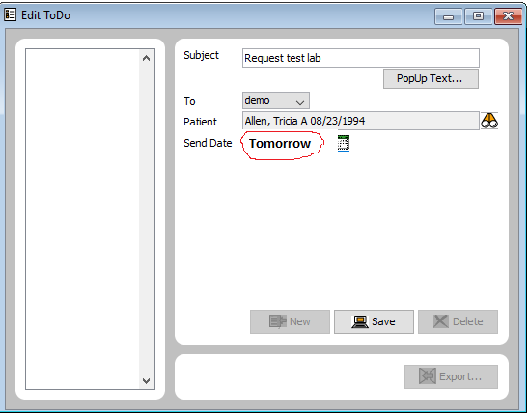

16.- Create this insure company:
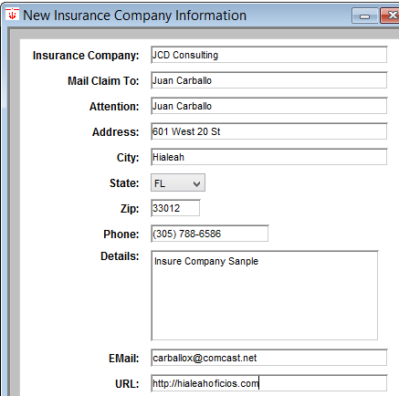

17.- Create this message and Chart it:
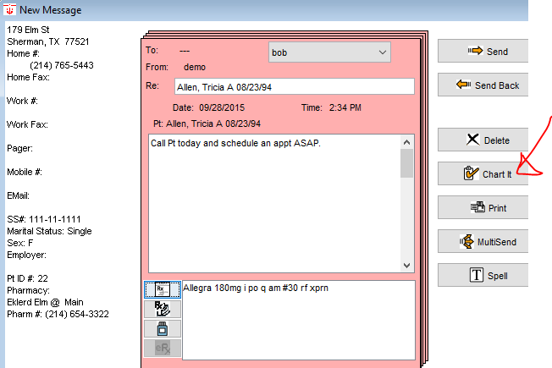

18.- Create this new address card:
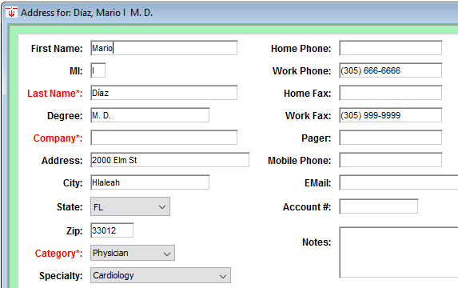

19.- Add this file cabinet document. Attach some doc.
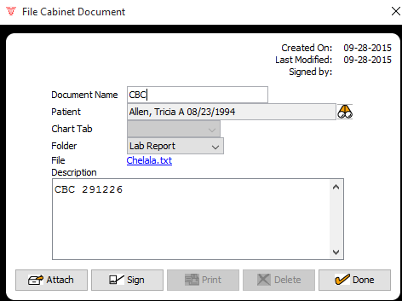

20.- Create this new farmacy:
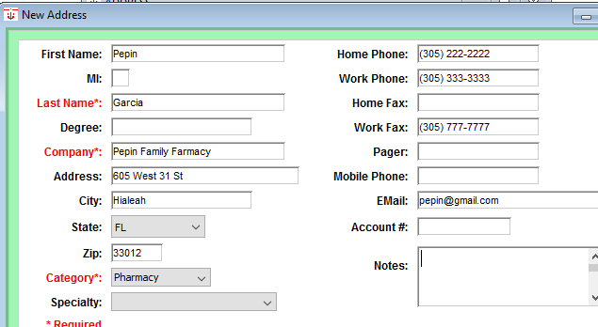

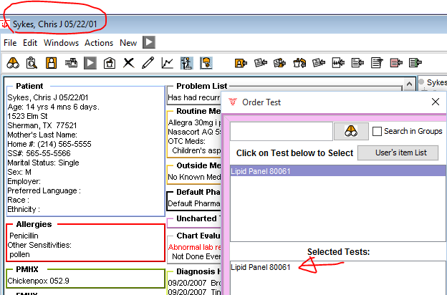
21.- Order this test:

22.- Fill the result for the pass test:
