CASE # 9A

1.- Create an appointment for:
- Patient: Pérez, Jose
- Day: Next Monday at 11:00 a.m.
- Provider:
- Notes: See the lab first.
2.- today like this image:
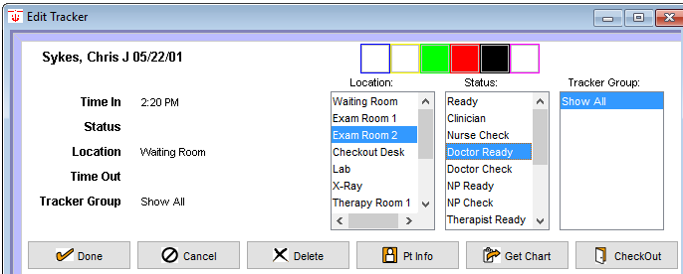

3.- Enable the track views like this image:
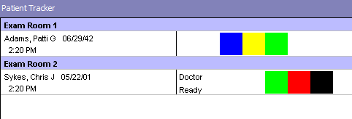

4.- Enter to the patient’s chart and take the vitals only like this image:
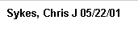
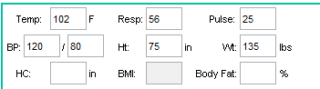

5.-

6.- Create a new refill like this image and save.
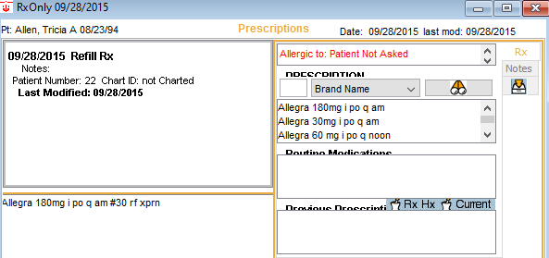
7.- Create a like this image and save.
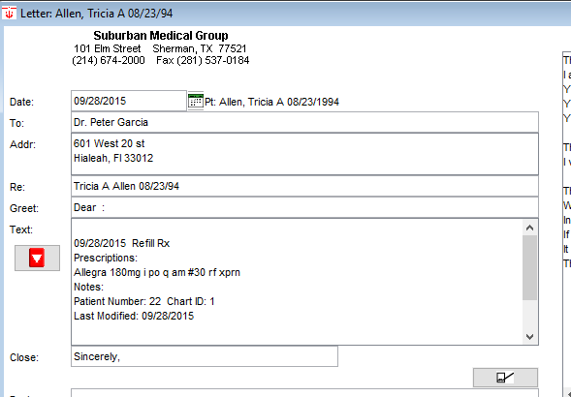
8.- Create a like this image and save
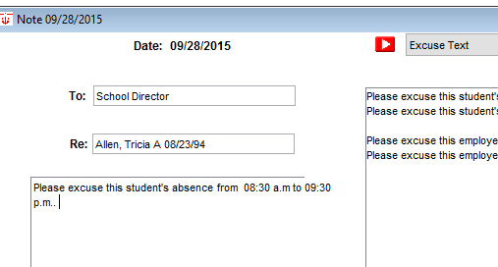

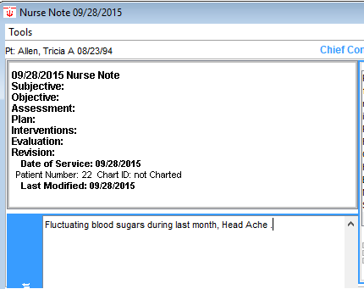
9.- Create a like this image and

10.- Create a like this image and
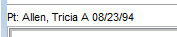
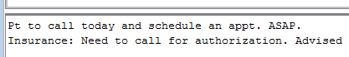

11.- Set the default farmacy to like this image:
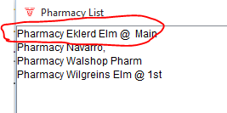

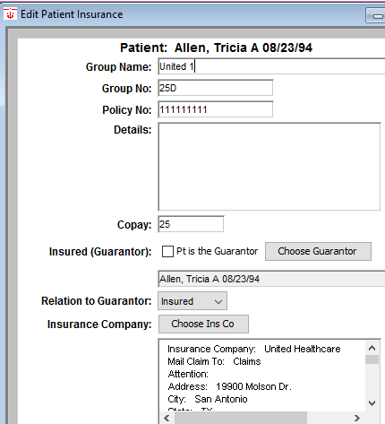
12.- Change the insurance company information:

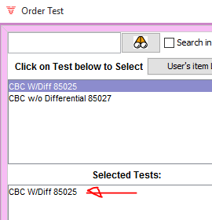

13.- Order a New CBC test for this patient.

14.- The result of pending CBC was:
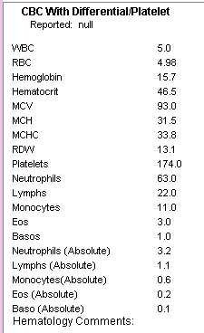

15.- Create a new to do list like this:
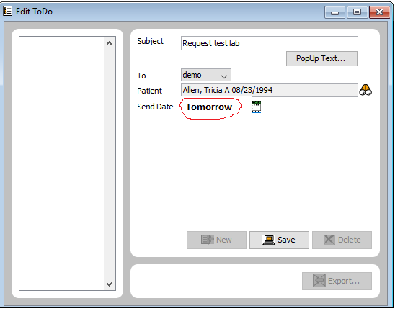

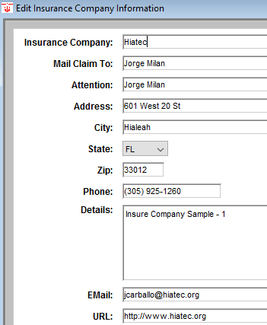
16.- Create this insure company:

17.- Create this message and Chart it:
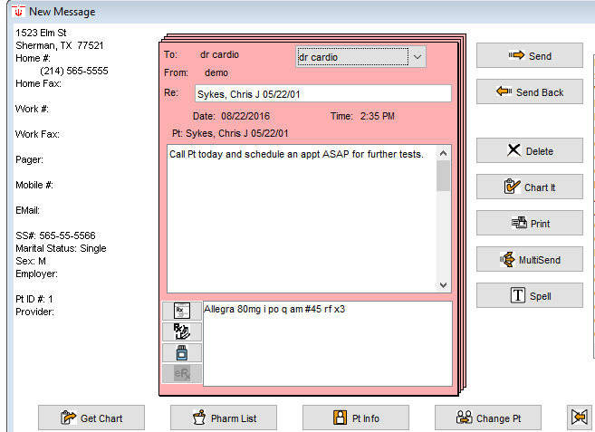

18.- Create this new address card:
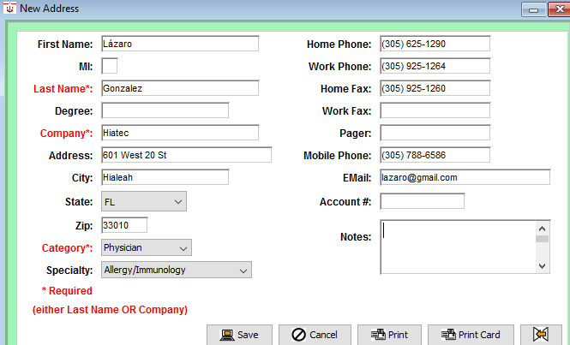

19.- Add this file cabinet document. Attach some doc.
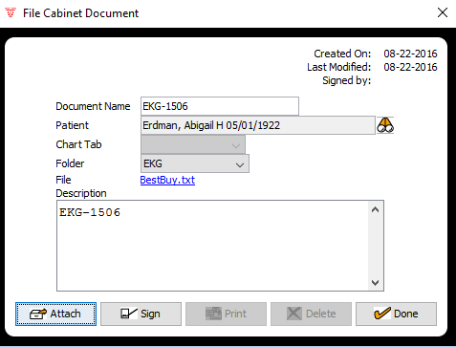

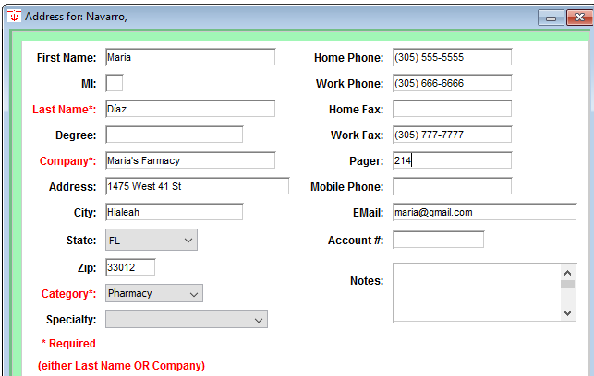
20.- Create this new farmacy:

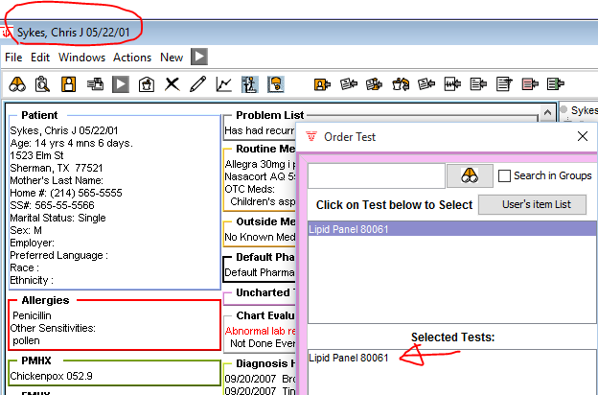
21.- Order this test:

22.- Fill the result for the pass test:
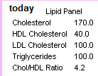

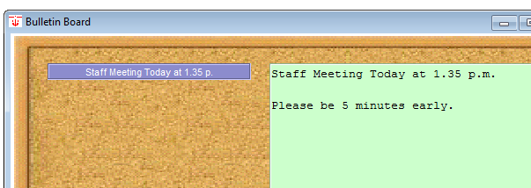
23.- Add a new bulletin board like this image:

24.- Calc the delivery date like this image:
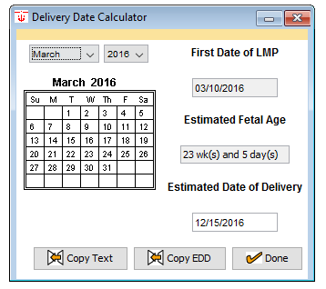

25.- Calc the Fº like this image:
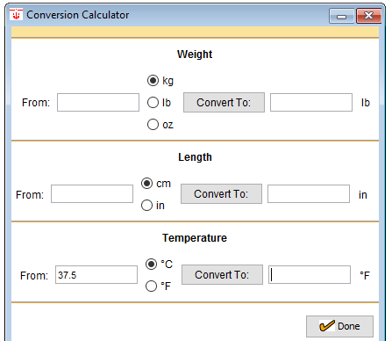

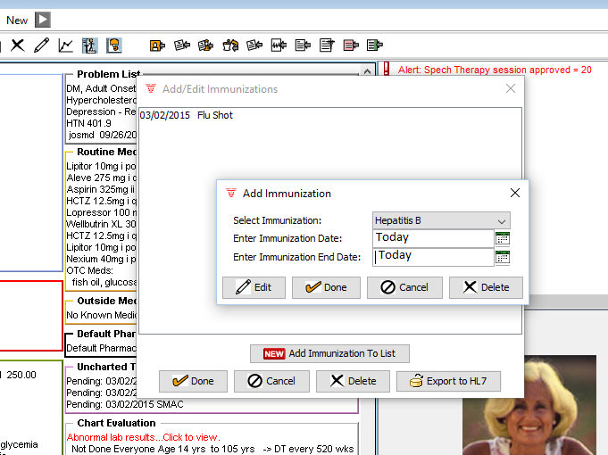
26.- Add a new immunization like this image:

